Comp 526

Programming Assignment 1

YUEFENG LIANG 201350099

**The problem.**

The bamboo fence cutting problem consists of bamboo that grow at different rates per day. It is required to find a repeating sequence to cut these bamboo shoots in a way that minimizes the quality factor (DH/H, H: the lower bound on the daily height in the limit; DH: the height of the currently tallest bamboo) over all time with the restriction that can only cut 1 bamboo a day.

**My General Strategy.**

**For Distribution 1：**

The strategy works in the following way, due to the H= GrowthRate[0]+...+GrowthRate[n-1] ( a constant ) and the quality factor is always greater or equal to 1, it is required to define a “max height restriction” for each bamboo shoot. This is a value that we are sure can be achieved for example, in the integer bamboo shoot problem we can guarantee that we can find an ordering which could make DH bigger than 42 but not too bigger, due to the H of these bamboos is 42.

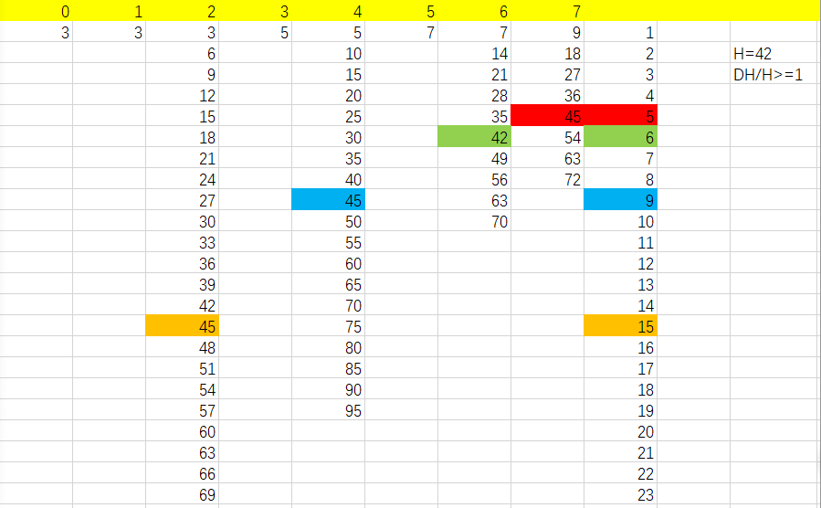

**Figure1. Integer bamboo shoot problem**

According to the figure, the max height restriction is used to reduce the search space in the following way. We conduct a normal brute force algorithm trying to find a non-repeating sequence that maintains our height restriction for a set number of cuts. The period of cutting 7th ,6th,4thand 2nd bamboo is more than 5, 6, 9 and 15 respectively. According to these periods, we could get the optimal sequence (7)->(4)->(3)->(6) ->(5) ->(7) ->(0) ->(6) ->(5) ->(4) ->(7) ->(1) ->(3) ->(0) ->(5) ->(7) ->(2).

**For Distribution 2**:

It is hard to use the normal brute force algorithm to find the optimal perque for the second problem. Thus, we try to use a method, called ReduceMax, a greedy method which each day cuts the tallest bamboo, regardless of the growth rates distribution. For example, the first day we get the height of bamboos (1,1,2,3,5,8,13,21), so we chose the 7th one to cut because it is the tallest one. Then we cut 6th bamboo as the height of bamboos increased to 2, 2, 4, 6, 10, 16, 26, 21. Thereby, we obtain one perque, 7, 6, 7, 5, 7, 6, 7, 4, 7, 6, 5, 7, 1, 6, 7, 3, 5, 7, 6, 4, 7, 2, 6, 7, 5, 7, 6, 7, 4, 1, 7, 6, 5, 7, 3, 6, 7, 4, 5, 7, 6, 1, 7, 1, 6, 7, 5, 2, 7, 6, 4, 7, 3, 5, 6, 7, 0, but we think this is not the optimal perque. Due to the operating time, we do not find the repeating part of this sequence, although the result is already close to the optimal value.

**For Distribution 3**:

We can see that the growth rates distribution of 3rd problem is showing the multiple relationship. It is easy to use normal brute force algorithm to find the optimal sequence. Because the H is 766, 768 is chose to be the max height restriction for all bamboos.

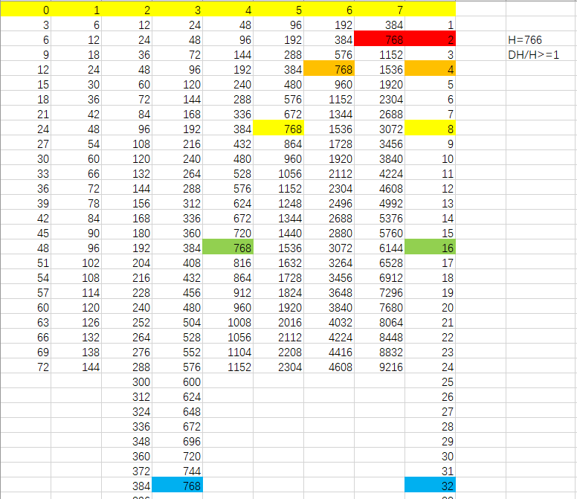

**Figure2. Distribution 3 Bamboo Problem**

According to the max height restriction, the periods of cutting each bamboo is 256, 128, 64, 32, 16, 8, 4 and 2 respectively. Thus, we could get one sequence by using brute force algorithm, 7, 6, 7, 5, 7, 6, 7, 4, 7, 6, 7, 5, 7, 6, 7, 3, 7, 6, 7, 5, 7, 6, 7, 4, 7, 6, 7, 5, 7, 6, 7, 2, 7, 6, 7, 5, 7, 6, 7, 4, 7, 6, 7, 5, 7, 6, 7, 3, 7, 6, 7, 5, 7, 6, 7, 4, 7, 6, 7, 5, 7, 6, 7, 1, 7, 6, 7, 5, 7, 6, 7, 4, 7, 6, 7, 5, 7, 6, 7, 3, 7, 6, 7, 5, 7, 6, 7, 4, 7, 6, 7, 5, 7, 6, 7, 2, 7, 6, 7, 5, 7, 6, 7, 4, 7, 6, 7, 5, 7, 6, 7, 3, 7, 6, 7, 5, 7, 6, 7, 4, 7, 6, 7, 5, 7, 6, 7, 7, 6, 7, 5, 7, 6, 7, 4, 7, 6, 7, 5, 7, 6, 7, 3, 7, 6, 7, 5, 7, 6, 7, 4, 7, 6, 7, 5, 7, 6, 7, 2, 7, 6, 7, 5, 7, 6, 7, 4, 7, 6, 7, 5, 7, 6, 7, 3, 7, 6, 7, 5, 7, 6, 7, 4, 7, 6, 7, 5, 7, 6, 7, 1, 7, 6, 7, 5, 7, 6, 7, 4, 7, 6, 7, 5, 7, 6, 7, 3, 7, 6, 7, 5, 7, 6, 7, 4, 7, 6, 7, 5, 7, 6, 7, 2, 7, 6, 7, 5, 7, 6, 7, 4, 7, 6, 7, 5, 7, 6, 7, 3, 7, 6, 7, 5, 7, 6, 7, 4, 7, 6, 7, 5, 7, 6, 7, 0.

**Results.**

**Distribution 1、**

The Perque is (7)->(4)->(3)->(6) ->(5) ->(7) ->(0) ->(6) ->(5) ->(4) ->(7) ->(1) ->(3) ->(0) ->(5) ->(7) ->(2)

Using the Strategy described above I managed to reduce my results to

Quotient= 1.2142857 MaxHeight= 51 H= 42

**Distribution 2**

The Perque is 7, 6, 7, 5, 7, 6, 7, 4, 7, 6, 5, 7, 1, 6, 7, 3, 5, 7, 6, 4, 7, 2, 6, 7, 5, 7, 6, 7, 4, 1, 7, 6, 5, 7, 3, 6, 7, 4, 5, 7, 6, 1, 7, 1, 6, 7, 5, 2, 7, 6, 4, 7, 3, 5, 6, 7, 0

Using the Strategy described above I managed to reduce my results to

Quotient= 1.5555556 MaxHeight= 84 H= 54

**Distribution 3**

The Perque is 7, 6, 7, 5, 7, 6, 7, 4, 7, 6, 7, 5, 7, 6, 7, 3, 7, 6, 7, 5, 7, 6, 7, 4, 7, 6, 7, 5, 7, 6, 7, 2, 7, 6, 7, 5, 7, 6, 7, 4, 7, 6, 7, 5, 7, 6, 7, 3, 7, 6, 7, 5, 7, 6, 7, 4, 7, 6, 7, 5, 7, 6, 7, 1, 7, 6, 7, 5, 7, 6, 7, 4, 7, 6, 7, 5, 7, 6, 7, 3, 7, 6, 7, 5, 7, 6, 7, 4, 7, 6, 7, 5, 7, 6, 7, 2, 7, 6, 7, 5, 7, 6, 7, 4, 7, 6, 7, 5, 7, 6, 7, 3, 7, 6, 7, 5, 7, 6, 7, 4, 7, 6, 7, 5, 7, 6, 7, 7, 6, 7, 5, 7, 6, 7, 4, 7, 6, 7, 5, 7, 6, 7, 3, 7, 6, 7, 5, 7, 6, 7, 4, 7, 6, 7, 5, 7, 6, 7, 2, 7, 6, 7, 5, 7, 6, 7, 4, 7, 6, 7, 5, 7, 6, 7, 3, 7, 6, 7, 5, 7, 6, 7, 4, 7, 6, 7, 5, 7, 6, 7, 1, 7, 6, 7, 5, 7, 6, 7, 4, 7, 6, 7, 5, 7, 6, 7, 3, 7, 6, 7, 5, 7, 6, 7, 4, 7, 6, 7, 5, 7, 6, 7, 2, 7, 6, 7, 5, 7, 6, 7, 4, 7, 6, 7, 5, 7, 6, 7, 3, 7, 6, 7, 5, 7, 6, 7, 4, 7, 6, 7, 5, 7, 6, 7, 0.

Using the Strategy described above I managed to reduce my results to

Quotient= 1.0039216 MaxHeight= 768 H= 765